|  |
| --- |
| Ravash inc. |
| Dylan’s Boaters Paradise |
| **Assignment 4** |
| Version #1.0  All work Copyright © 2012 by Ravash inc.  All rights reserved. |
| **Dylan Scott** |
|  |

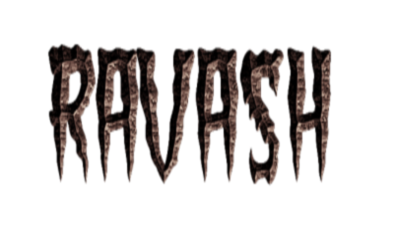

|  |
| --- |
| July 11th 2012 |

**Table of Contents**

1. Version History
2. Detailed Application Description
3. Controls
4. Interface Sketch
5. Screen Shots
6. Characters / Vehicles
7. Enemies
8. Scoring
9. Sound Index
10. Art / Multimedia Index

# 

# Version History

Mailpilot.py – The Very basic mailpilot.py that was given out with minimal changes.

Version 0.1- So far I changed the player sprite to a boat and changed the direction of the ocean to go sideways and simulate the boat travelling to the right. I plan on using the same ocean background as mailpilot because it fits my game as well.

Version 0.2 - In this version so far I have the island class (Which i plan on keeping because it goes well with the boating theme (It being summer time and all and I'm trapped in school)). I've added the shark enemy class to my game. This will be the 2nd enemy my game has with the 3rd being placed in the next version. This version has much code I still wish to add/take out.

Version 0.3- In this version I've added the Balloon class to the friendly list and an objective for the player to collect. I’ve added two island's to the enemy list to increase difficulty. I’ve added the Submarine class to be the Big slow enemy of the game. Ive changed the way the sprites are written to the background so the islands are on top of everything else.

Version 1.0 – In this version I've added the game sounds for my new game (Now that I have internet again I can get files again). I’ve cleaned up the code and now the file is ready for submission!

# 

# Detailed Application Description:

My program is a side scrolling adventure that puts the player on a boat desperately trying to collect his prized Balloon collection. To get your balloons back you must navigate dangerous waters and avoid enemies to get as many balloons back as possible. But be careful, with only 5 spare engines on board you must be careful to avoid everything.

# Controls:

My program’s controls can be controlled 100% by mouse dragging.

# Interface Sketch:

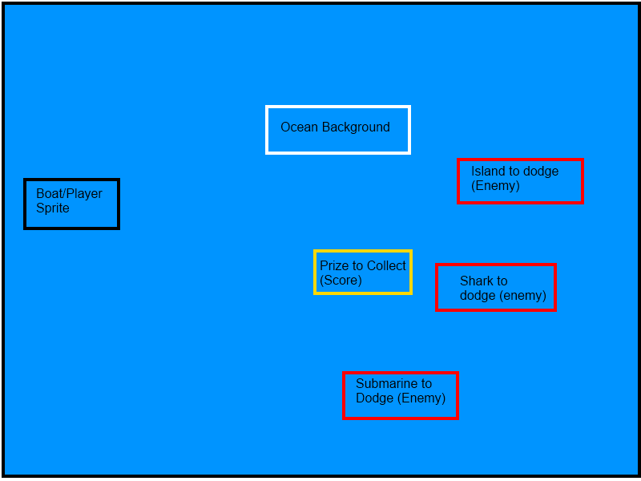

# Screen Descriptions:

## Intro Screen :

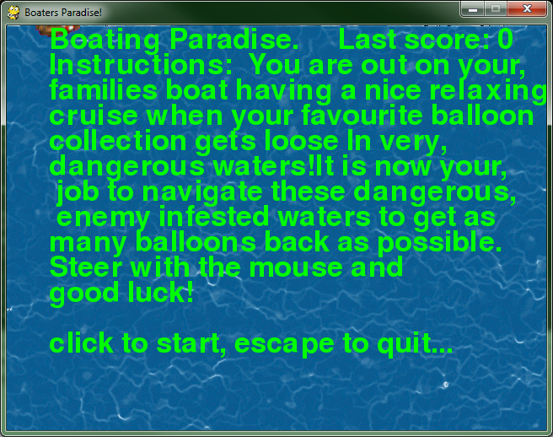

## Game Screen :

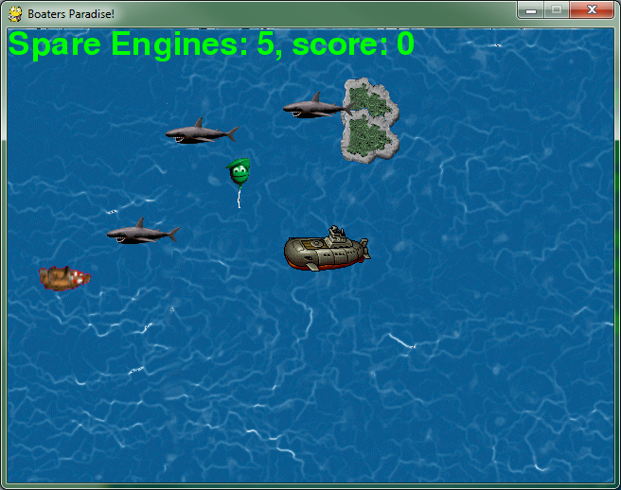

## Play again Screen:

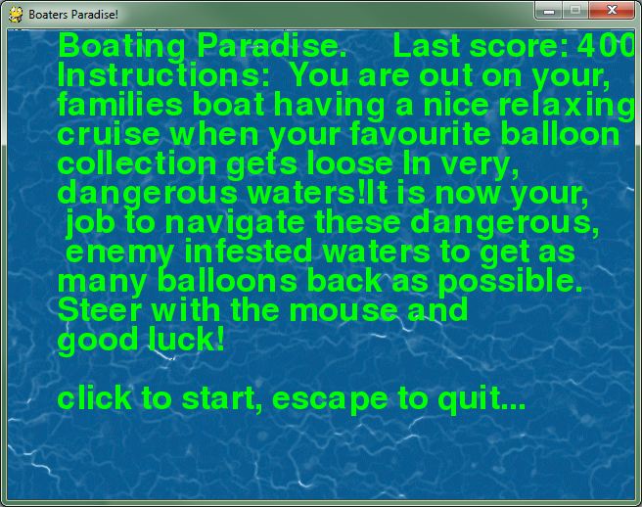

# Character / Vehicles:

The character controls a small motor boat in this game. The boat design was originally from Donkey Kong Country 3.

# Enemies:

The enemies include 3 sharks, 2 islands and a giant sub. The Sharks have the fastest base move speed possible while the Sub and the Island have the lowest base speed.

# Scoring:

Every time a balloon is collected the player gains 100 score. The more balloons gathered in one game session the better!

# Sound index:

All my sounds came from the website <http://www.freesfx.co.uk/soundeffects>.

# Art / Multimedia Index:

The images used for my sprites came from either Google.com image search or from http://spriters-resource.com/.